RESOLUTION NO.__________

RE: CERTIFICATE OF APPROPRIATENESS UNDER THE
PROVISIONS OF THE ACT OF THE PENNSYLVANIA
LEGISLATURE 1961, JUNE 13, P.L. 282 (53
SECTION 8004) AND BETHLEHEM ORDINANCE NO.
3952 AS AMENDED.

The applicant proposes to replace the siding, replace storm doors and windows and paint the exterior trim at 33 E. Wall St.

NOW, THEREFORE, BE IT RESOLVED by the Council of the City of Bethlehem that a Certificate of Appropriateness is hereby granted for the proposal.

Sponsored by: (s)

(s)

ADOPTED BY COUNCIL THIS DAY OF

(s)
President of Council

ATTEST:

(s)
City Clerk

HISTORICAL & ARCHITECTURAL REVIEW BOARD

The applicant proposes to replace the siding, replace storm doors and windows and paint the exterior trim at 33 E. Wall St.

APPLICATION #3:

Robert & Christine Kruklitis
33 E. Wall St.
Bethlehem, PA 18018

OWNER:

__________________________________________________________________________

The Board upon motion by Phil Roeder and seconded by Diana Hodgson adopted the proposal that City Council issue a Certificate of Appropriateness for the following:

- To re-side and replace specific non-historic windows and repaint the trim.

2. Color scheme to be: siding: Booth Bay Blue, trim: Valspar #7002-16 Swiss Copper,
door: SW#6328 Fire Weed, with windows and trim color to match.

3. The motion was unanimously approved.

__________________________________________________________________________

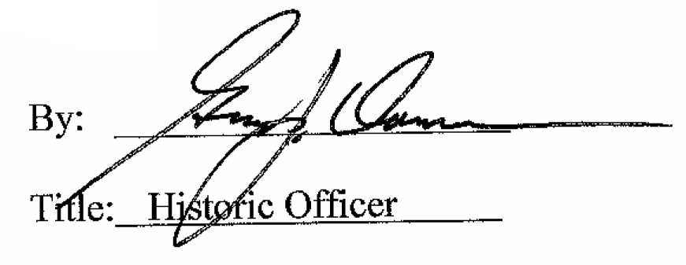

Date of Meeting: August 1, 2018

